**Practical 1 :- Explain Arduino, Arduino Pin Diagram, Arduino Architecture and Arduino IDE.**

An arduino is the open source microcontroller kit which is based on easy to use software and the hardware.it is basically used in communication and controlling and any other devices.

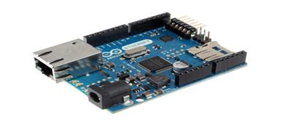

**Arduino pin diagram:-**

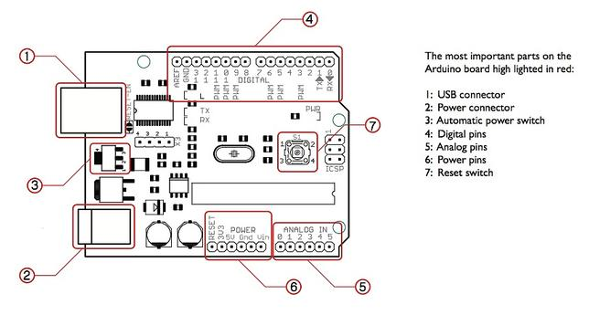

An arduino board is basically called the arduino uno.it consists of atmega328 a 28 pin microcontroller.

1)USB connector:-

Arduono can be powered either on the computer through the usb connector.

2)Power connector:-

We can operate arduino by using the external battery or the power supply via 7 to 12v.

3)Digital pins:-

It consists of 14 digital inputs/output pins, each of which provide or take up 40mA current. Some of them have special functions like pins 0 and 1, which act as Rx and Tx respectively , for serial communication, pins 2 and 3-which are external interrupts, pins 3,5,6,9,11 which provides power output and pin 13 where the LED is connected.

4)Analog pins:-

It has 6 analog input/output pins, each providing a resolution of 10 bits.

5)Reset switch:-

It resets the microcontroller when low.

**Arduino architecture:-**

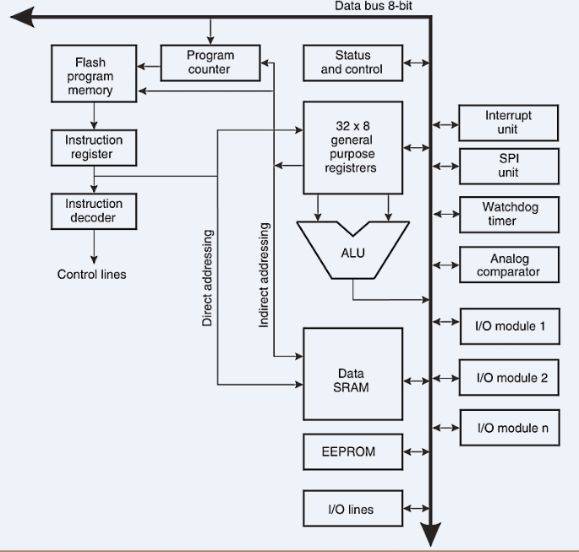

Arduino’s processor basically uses the Harvard architecture where the program code

and program data has separate memory. It consists of two memories- Program

memory and the data memory. The code is stored in the flash program memory,

whereas the data is stored in the data memory. The Atmega328 has 32 KB of flash

memory for storing code (of which 0.5 KB is used for the bootloader), 2 KB of SRAM

and 1 KB of EEPROMand operates with a clock speed of 16MHz.

**Arduino IDE:-**

The Arduino IDE is an open-source software, which is used to write and upload code to the Arduino boards. The IDE application is suitable for different operating systems such as Windows, Mac OS X, and Linux. It supports the programming languages C and C++. Here, IDE stands for Integrated Development Environment.

The program or code written in the Arduino IDE is often called sketching. We need to connect the Genuino and Arduino board with the IDE to upload the sketch written in the Arduino IDE software. The sketch is saved with the extension '.ino.'

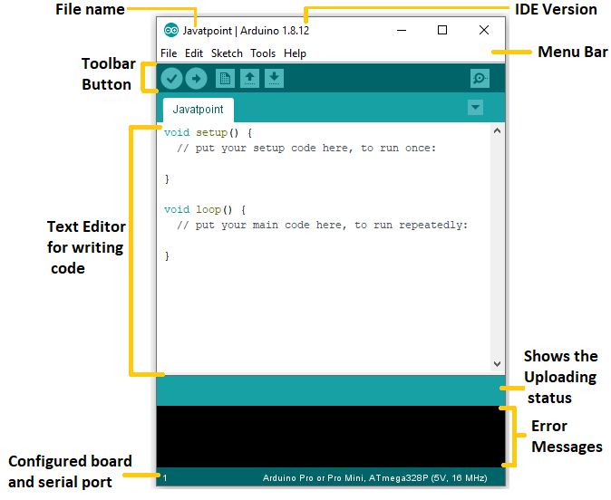

**Practical 2 :-Blink LED with Arduino.**

Step-1:-First of all we have to connect the arduino circuit with the 5v power to the usb port converter cable.after the connect of the arduino circuit we have to remove or delete the old program on the arduino ide.

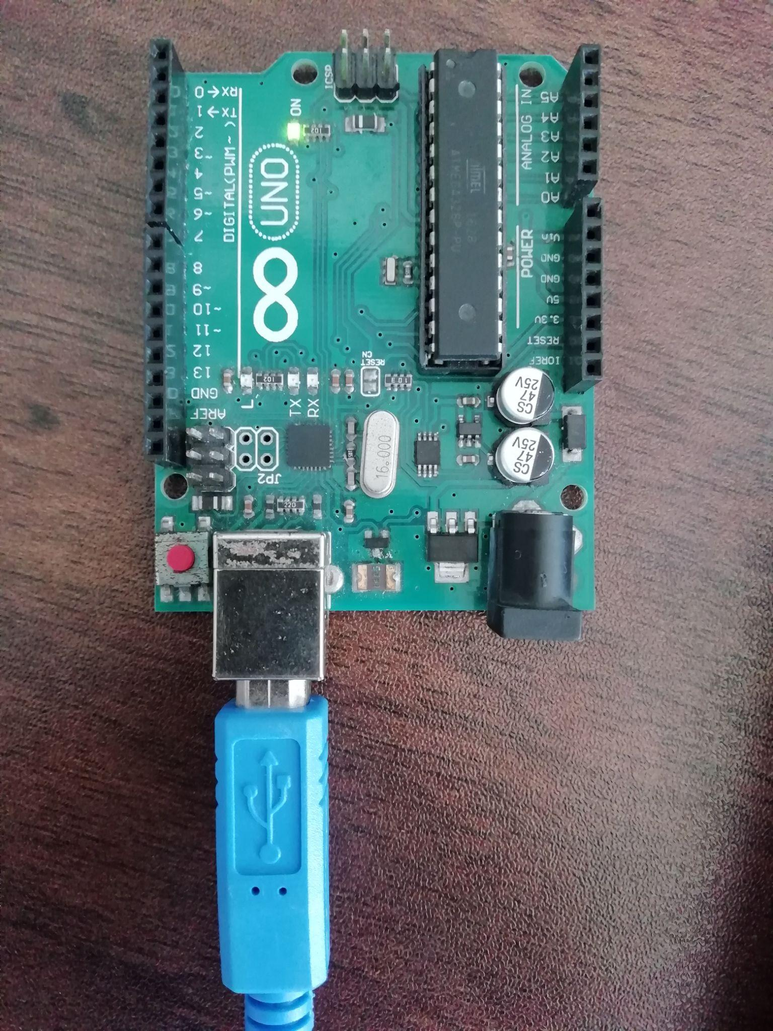

(image of the blinking light on the arduino circuit)

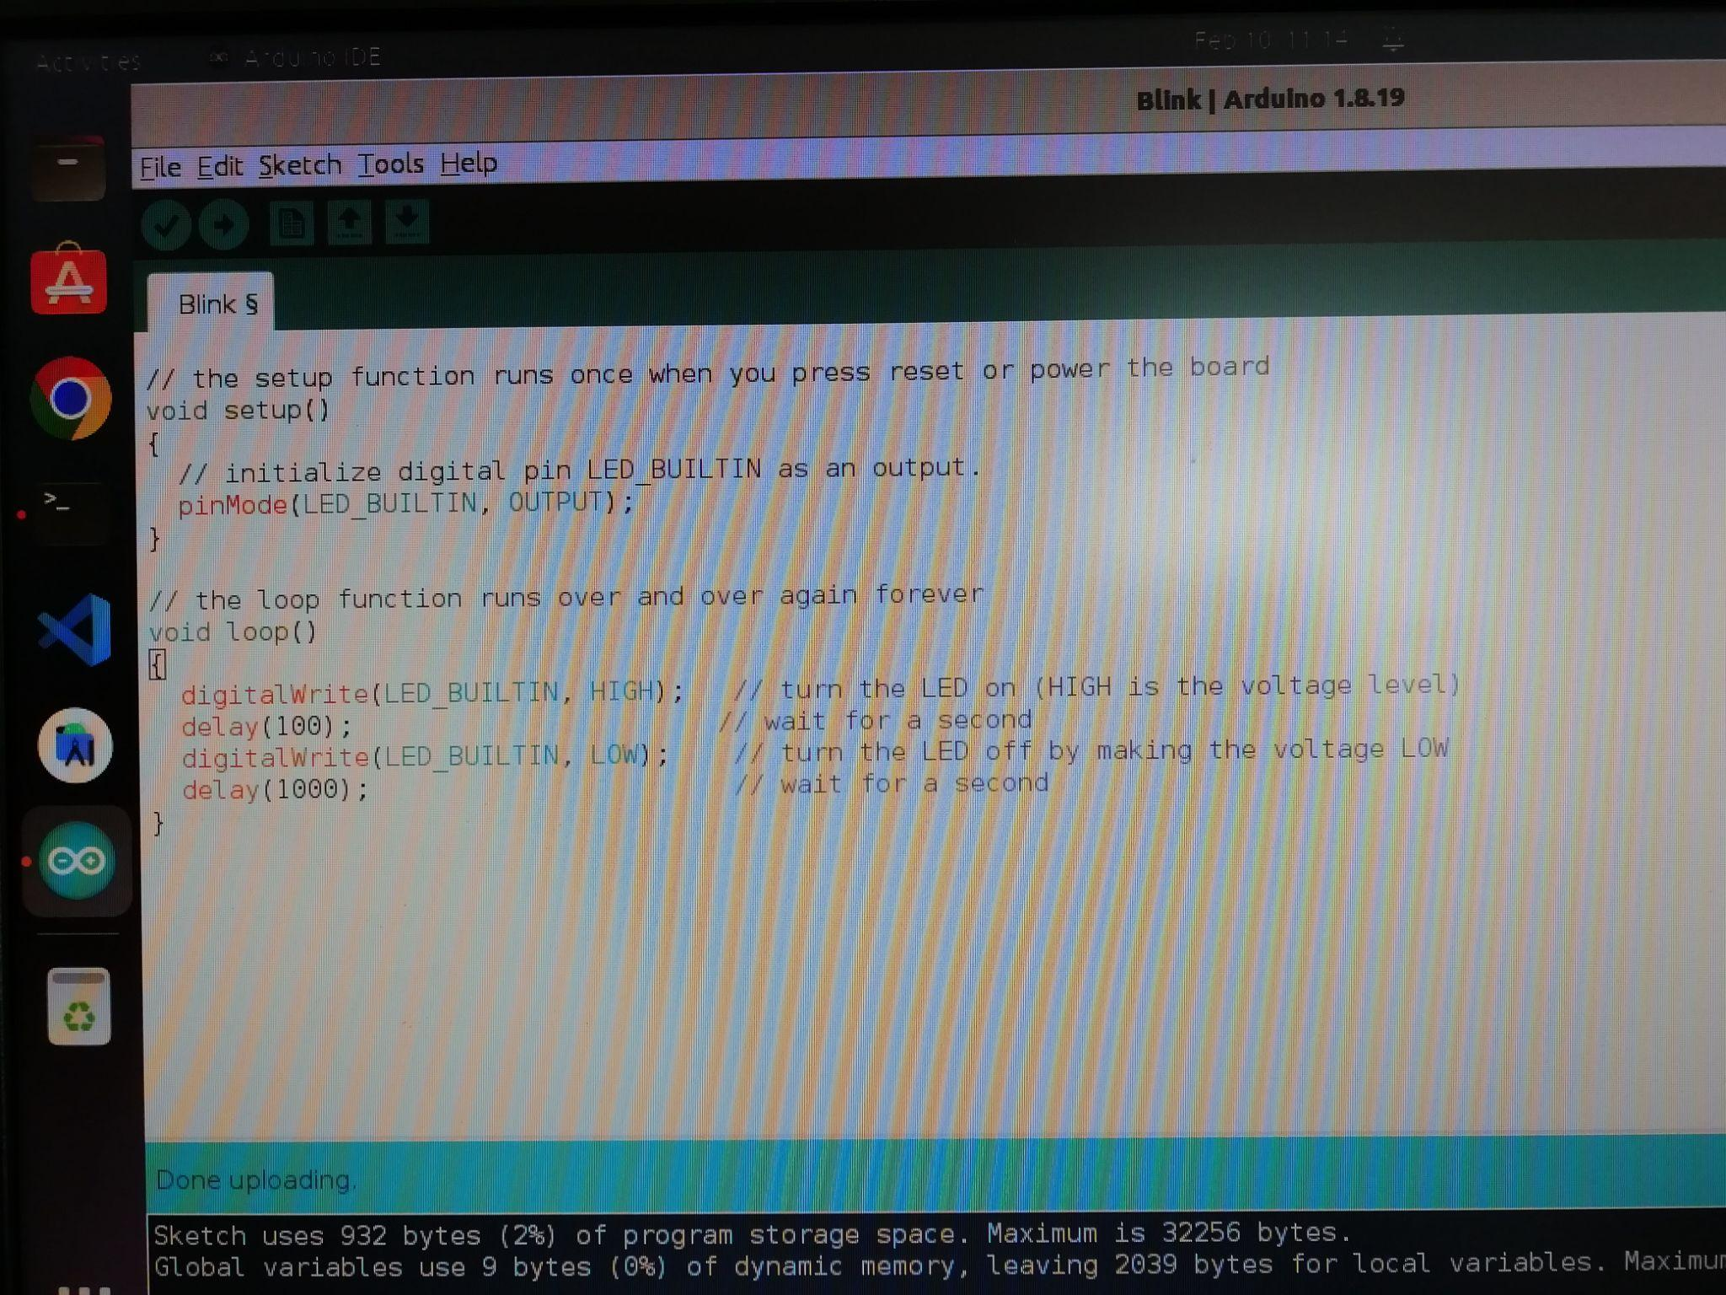

(code for blinking the light on the arduino circuit)

Step-2:- There are the pre-written codes for the different-different task as your requirement.after the code written you have to verify that code and upload on the arduino board during the upload task your arduino circuit will blink twice that means your code successfully uploads on it.

Step-3:-Then after your task is complete just perform on the light blinking time and delay which is in milliseconds.

**Practical 2 :-Blink LED with Arduino using breadboard.**

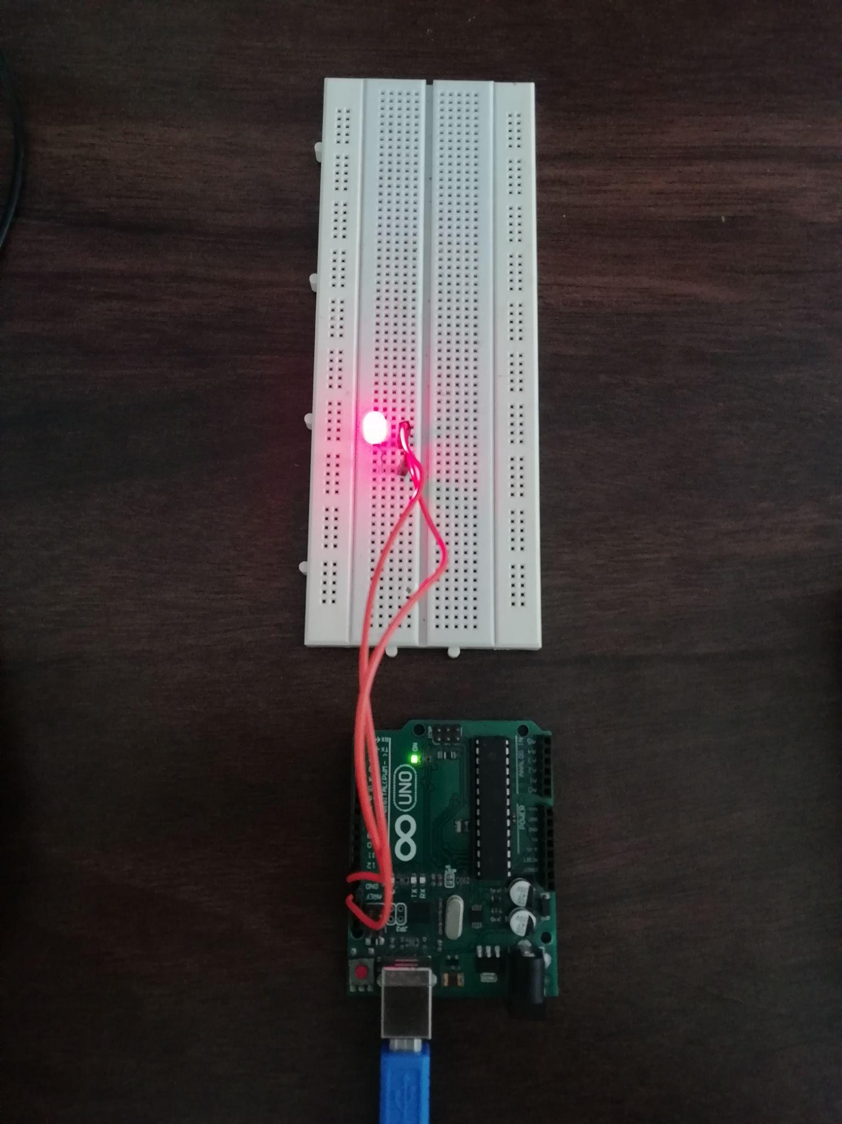

(image of the blinking light on breadboard using the arduino circuit)

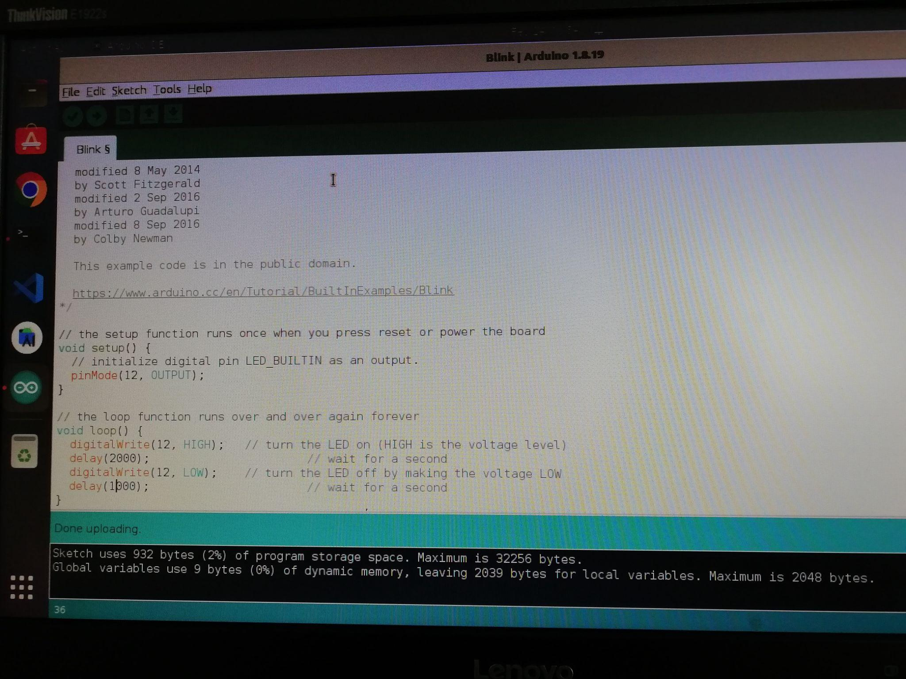

(code for blinking the light on the arduino circuit)

Step-1:-First of all we have to connect the arduino circuit with the 5v power to the usb port converter cable.after the connect of the arduino circuit we have to remove or delete the old program on the arduino ide.

Step-2:-you have to insert the led light on the breadboard and then insert the wire in the 12 number pin and insert the second wire in the gnd pin.

Step-3:-in the breadboard gnd wire connect the right side of the led light and 12 number pin wire connect the left side of the led light on the breadboard.  
Then after you have to open the arduino ide and there are the pre-written codes for the different-different task as per your requirement.

Step-4:-After the code written you have to write pin number of the light (12) instead of LED_BUILTIN then verify that code and upload on the arduino board during the upload task your arduino circuit will blink twice that means your code successfully upload on it.then after your task is complete just perform on the milliseconds of the light blinking time and delay which is in seconds.

**Practical 3 :-Perform Experiment using Arduino to measure the distance of any object using Ultrasonic Sensor.**

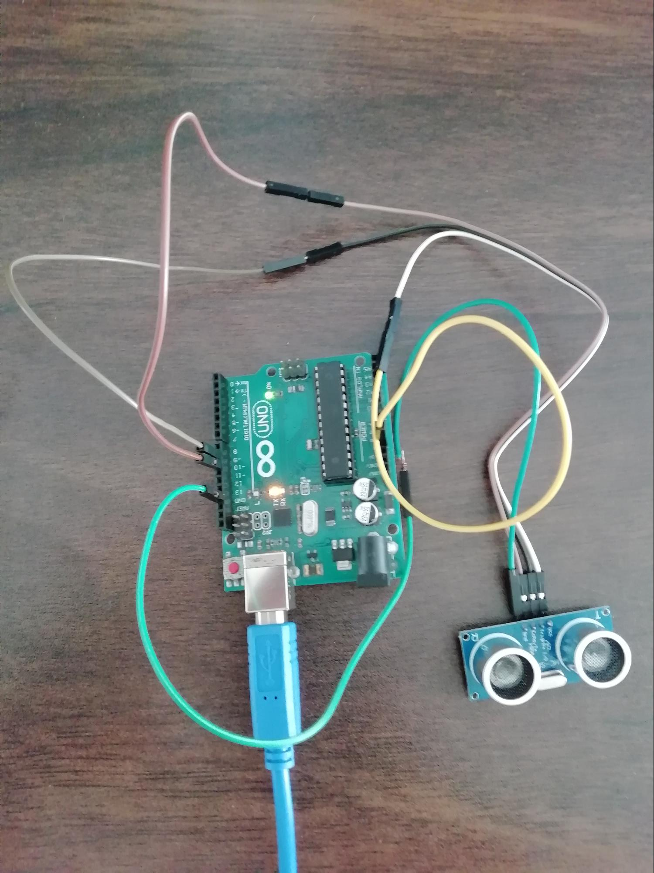

Step-1:- first of all you need to connect the ultrasonic sensor with the arduino circuit.so first step is there is 4 connection ports in the ultrasonic sensor first one is the vcc,second one is the trigpin,3rd one is the echopin and 4ht is the ground.

Step-2:-connect all the ultrasonic sensor ports with the arduino circuit.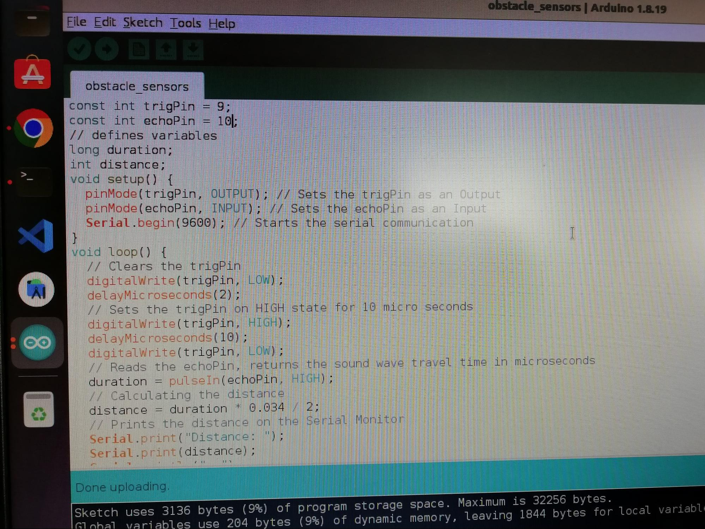

step-3:-Enter the trigpin and the echopin number of the arduino circuit where you insert the cable on the arduino circuit.

Step-4:-verify your code and just upload it on the arduino circuit.

Step-5:- measure the distance of the obstacle.

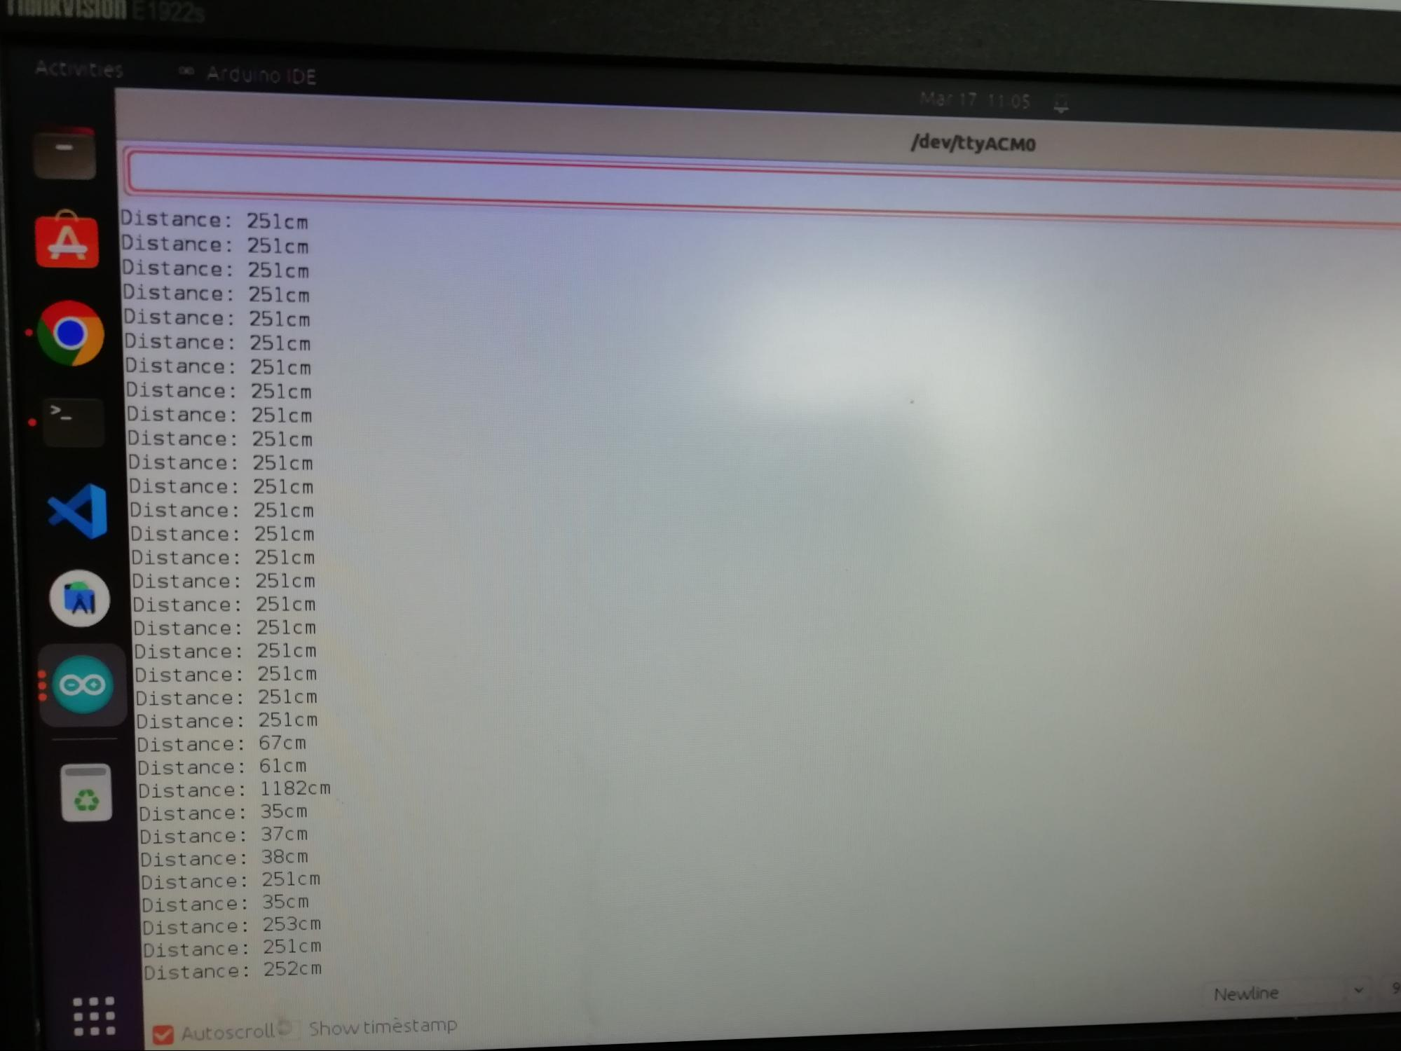

**Practical 4 :-Interfacing the LM35 Sensor with Arduino and Write a Program to Print Temperature and Humidity reading.**

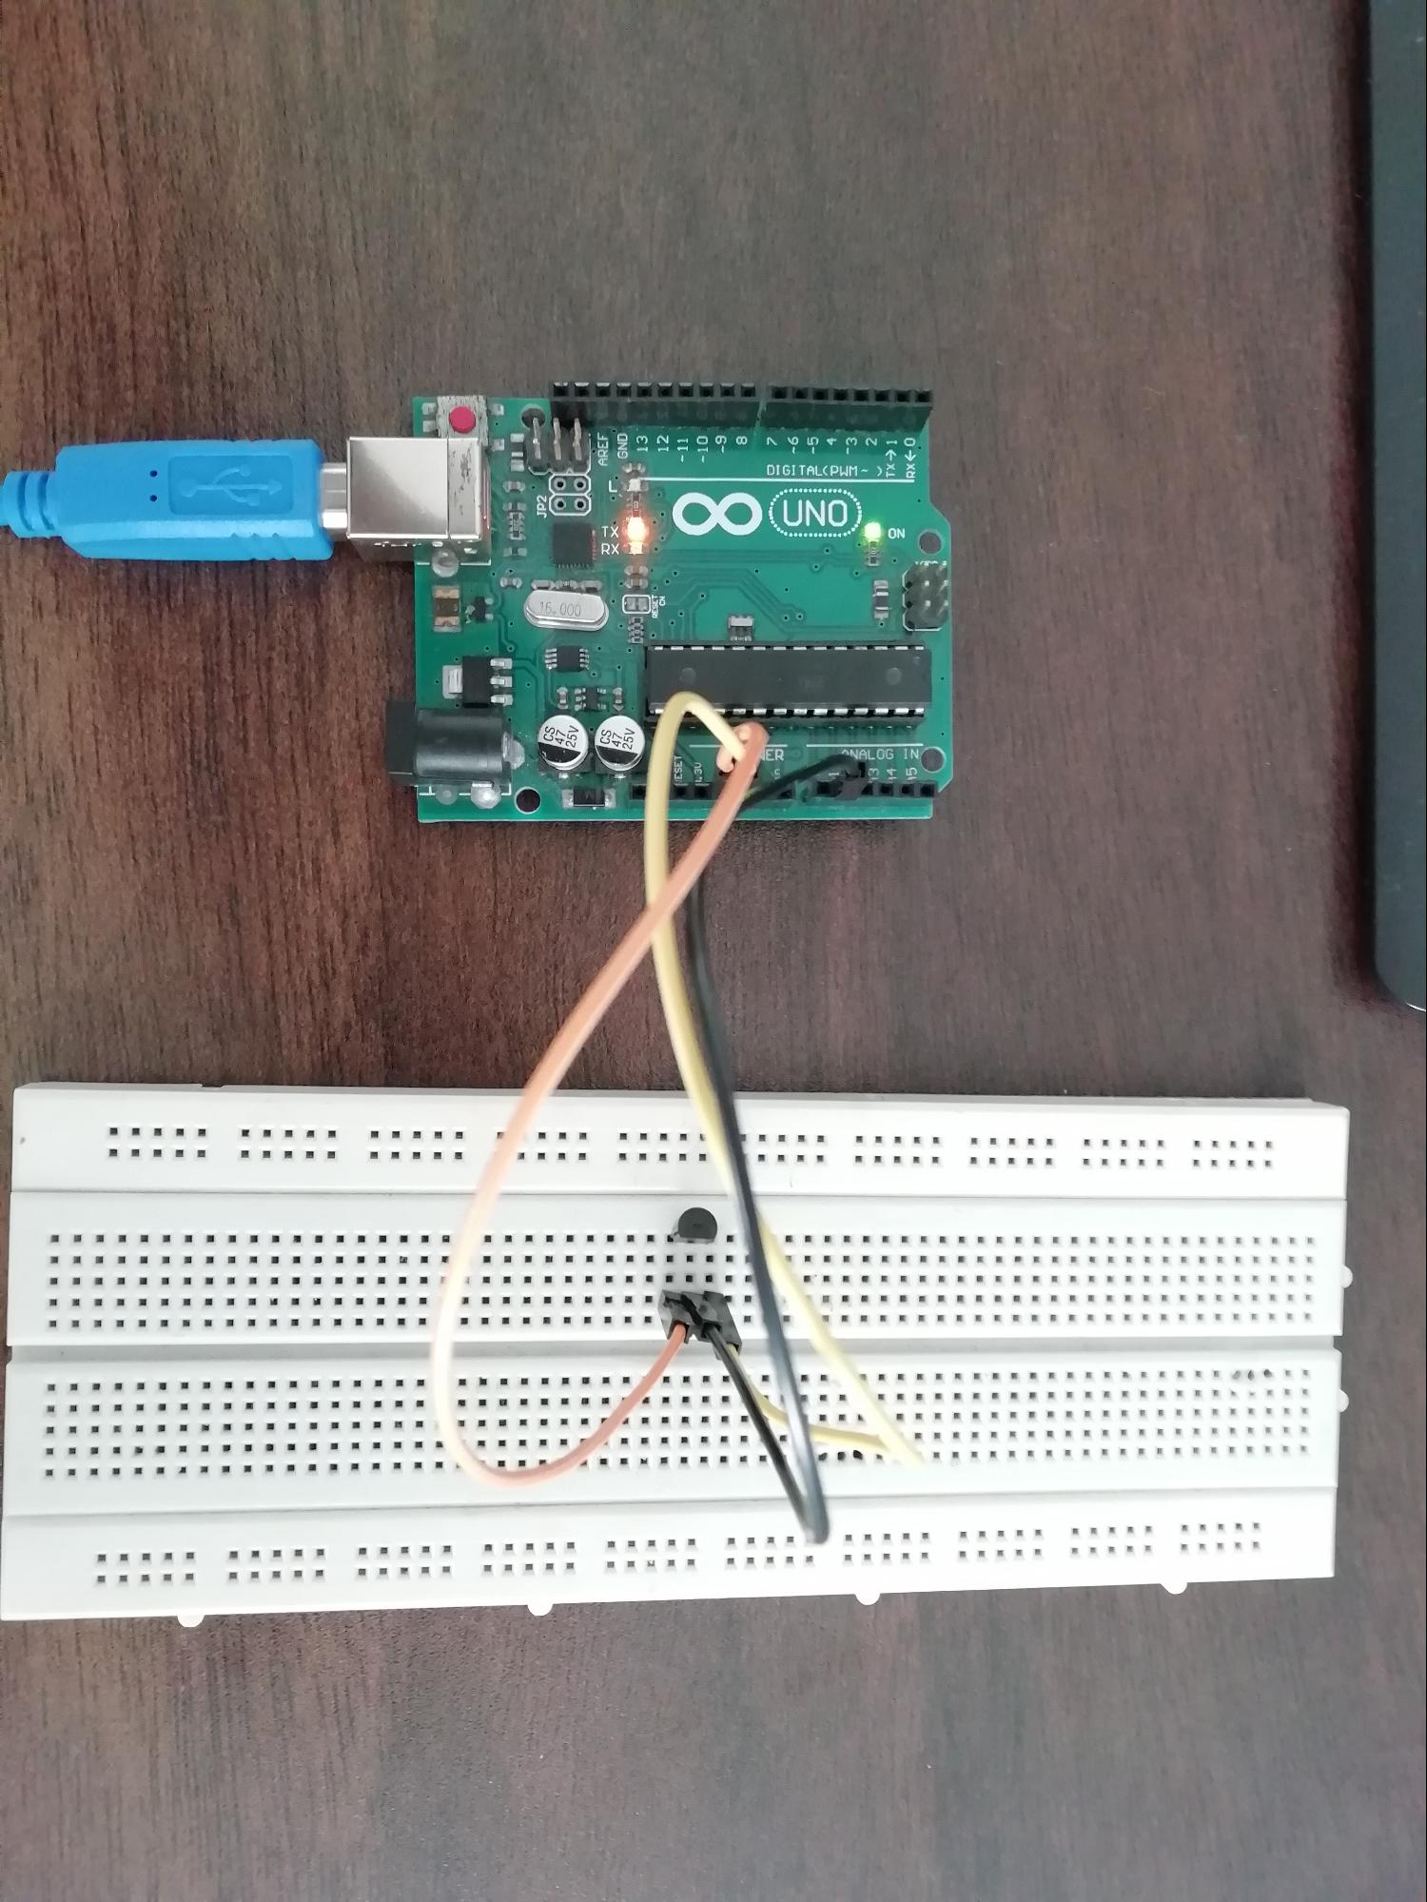

Step-1:- here we are using the LM35 sensor to measure the temperature.

Step-2:- connect the LM35 sensor. The first pin is a Vcc,the second one is an analog input pin(read the analog pin number),and the third one is the ground.

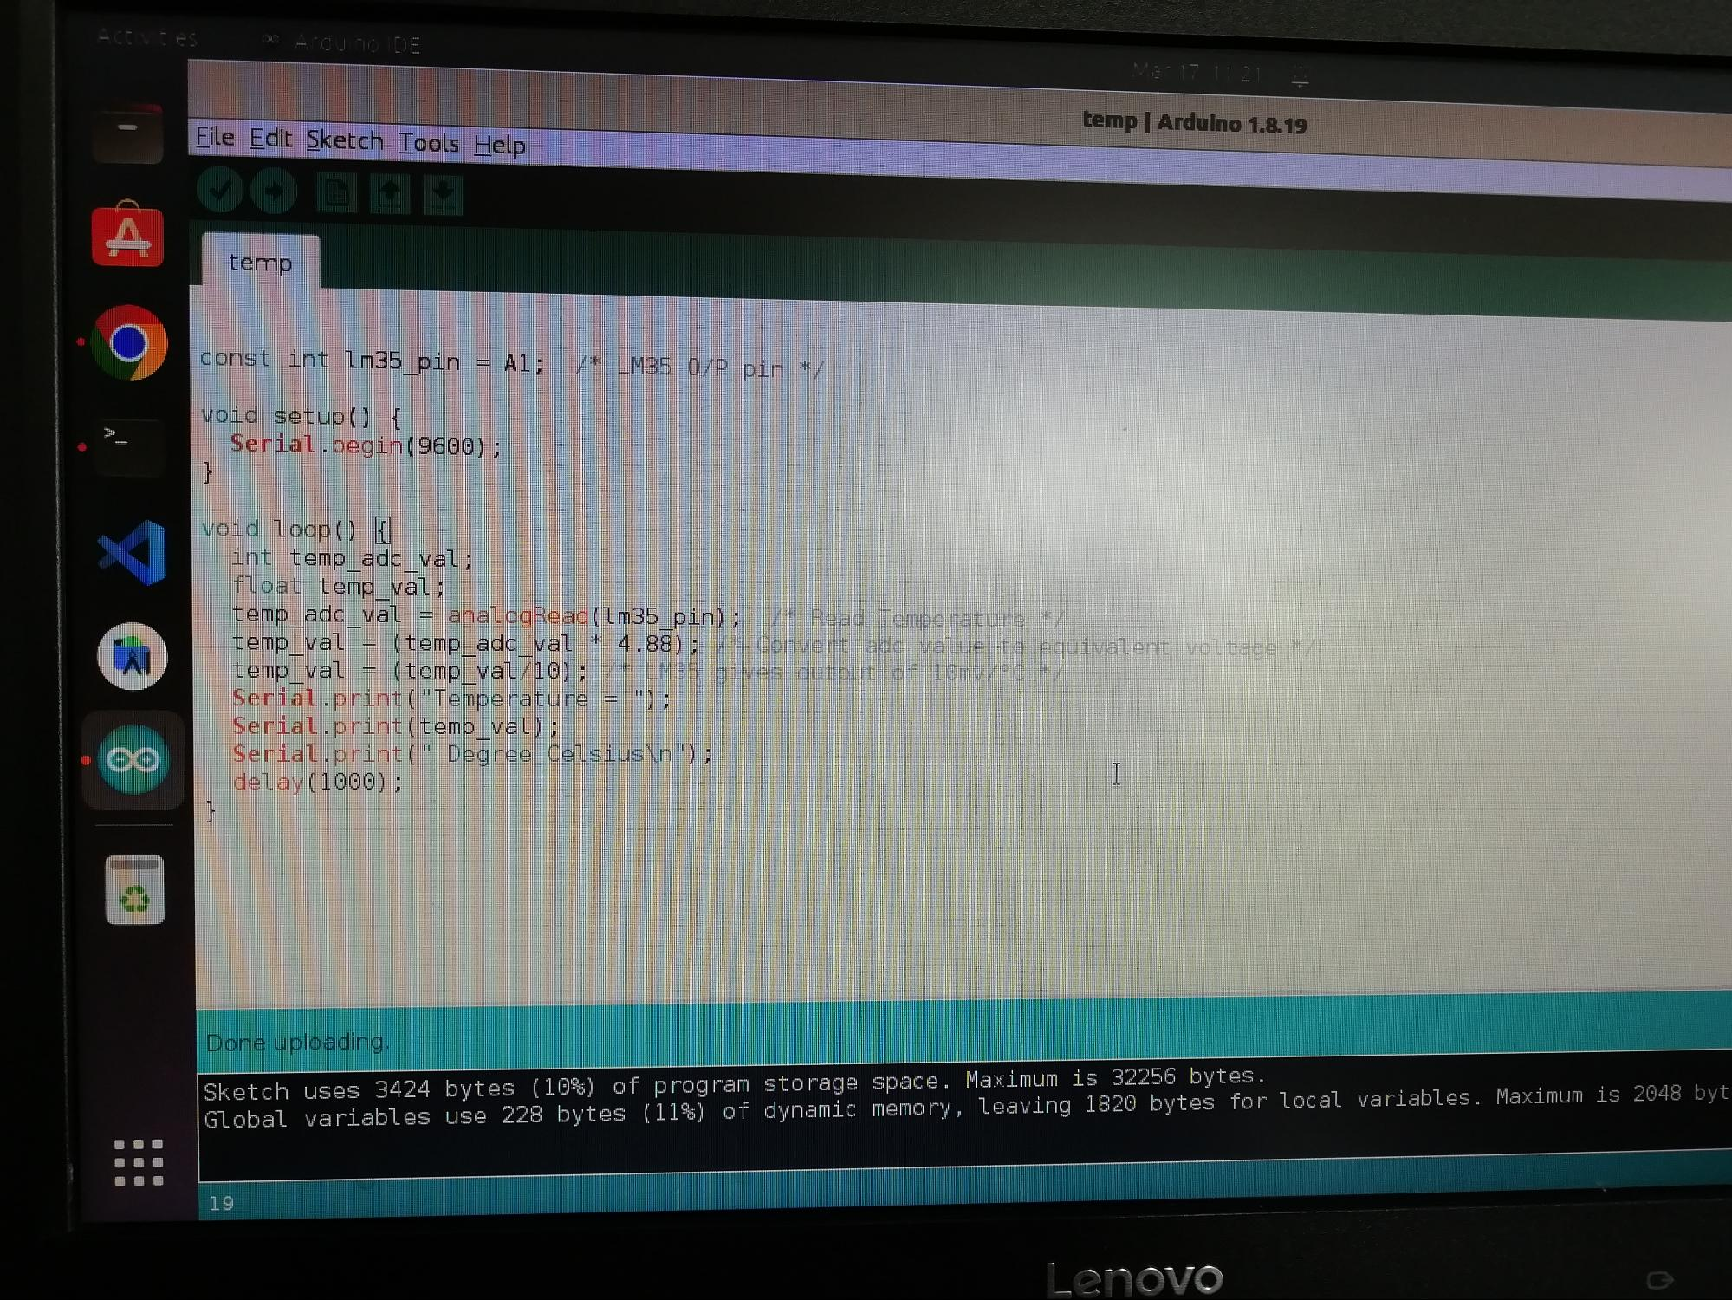

Step-3:-enter the analog input number in the code and verify the code and upload on the arduino circuit.

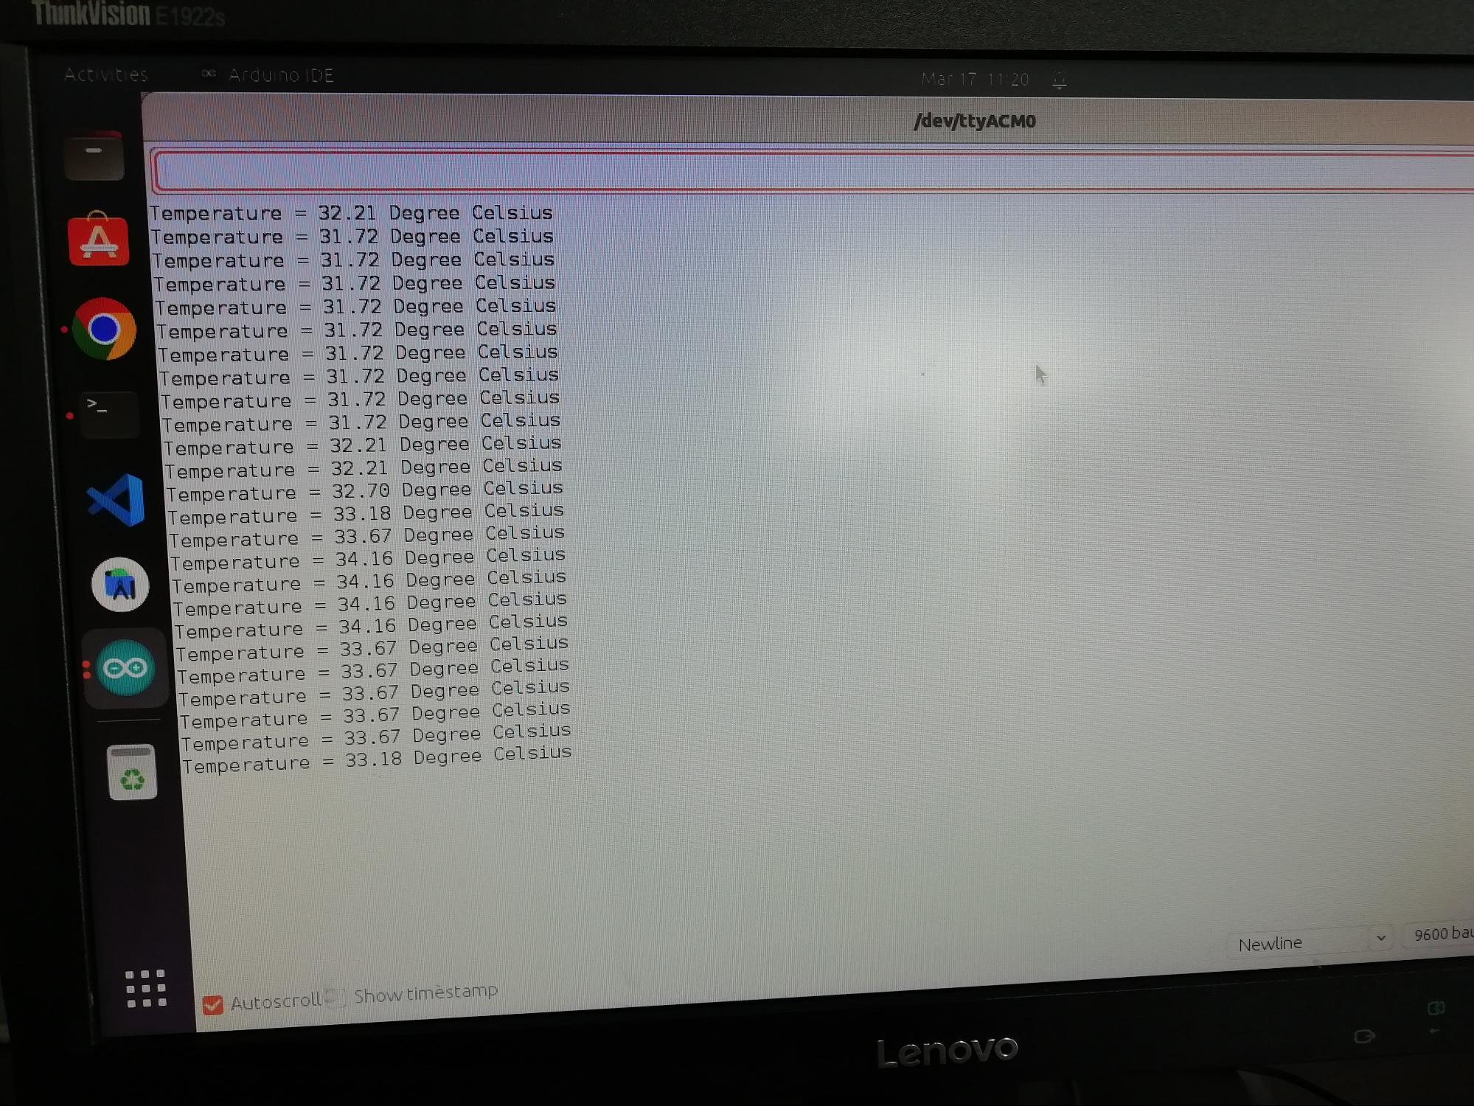

Step-4:-here you can see the temperature reading around the LM35 sensor.

**Practical 5 :-Interfacing the Heartbeat Sensor with Arduino.**

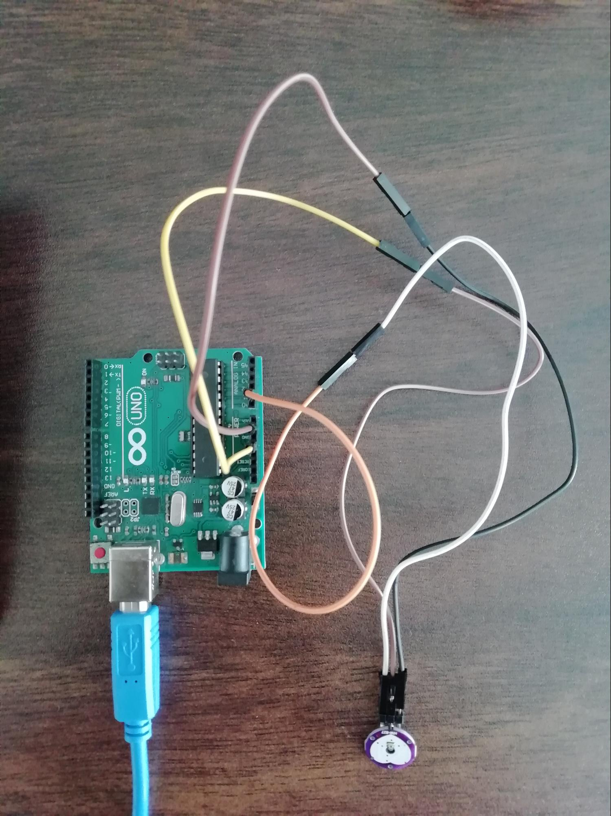

Step-1:- Here we are using the pulse sensor to measure the heartbeat reading.so we need to connect the pulse sensor to the arduino circuit.

Step-2:- there are 3 pins. The first one is the vcc,ground,and analog in.

Step-3:- connect the pulse sensor with the arduino circuit and here we are using the inbuilt light for led blink.

Step-4:- set the threshold value 550 when the signal above the 550 led will glow on the arduino circuit if the signal will measure below 550 the led will turn off.

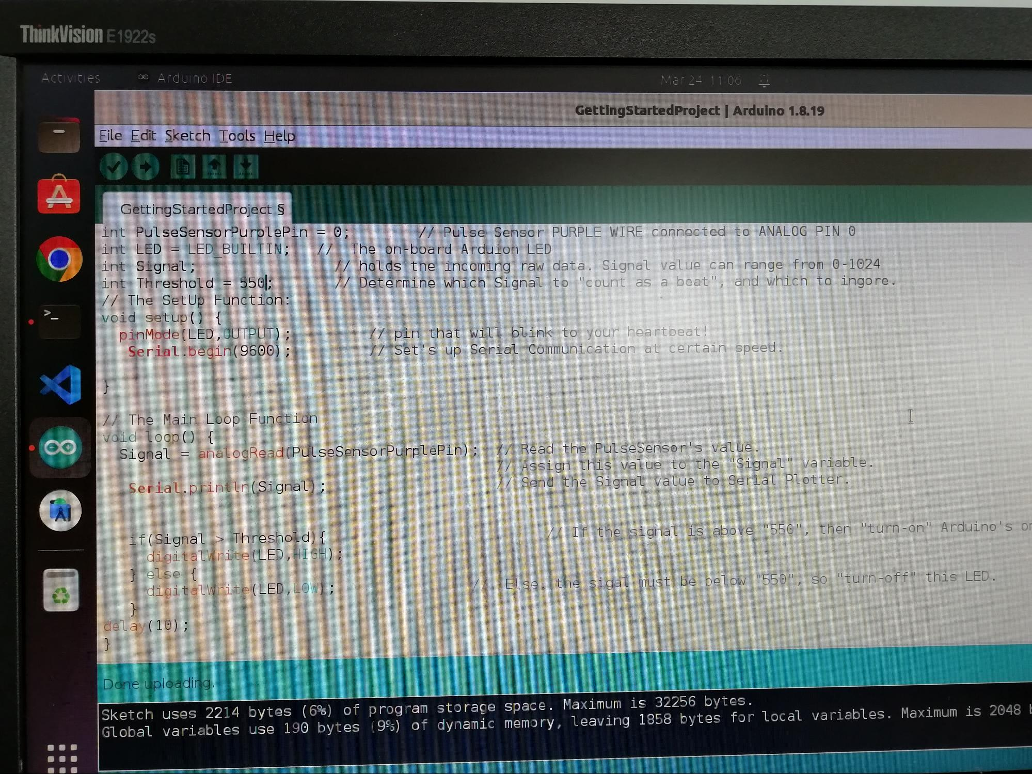

Step-5:- verify the code and upload it on the arduino circuit.

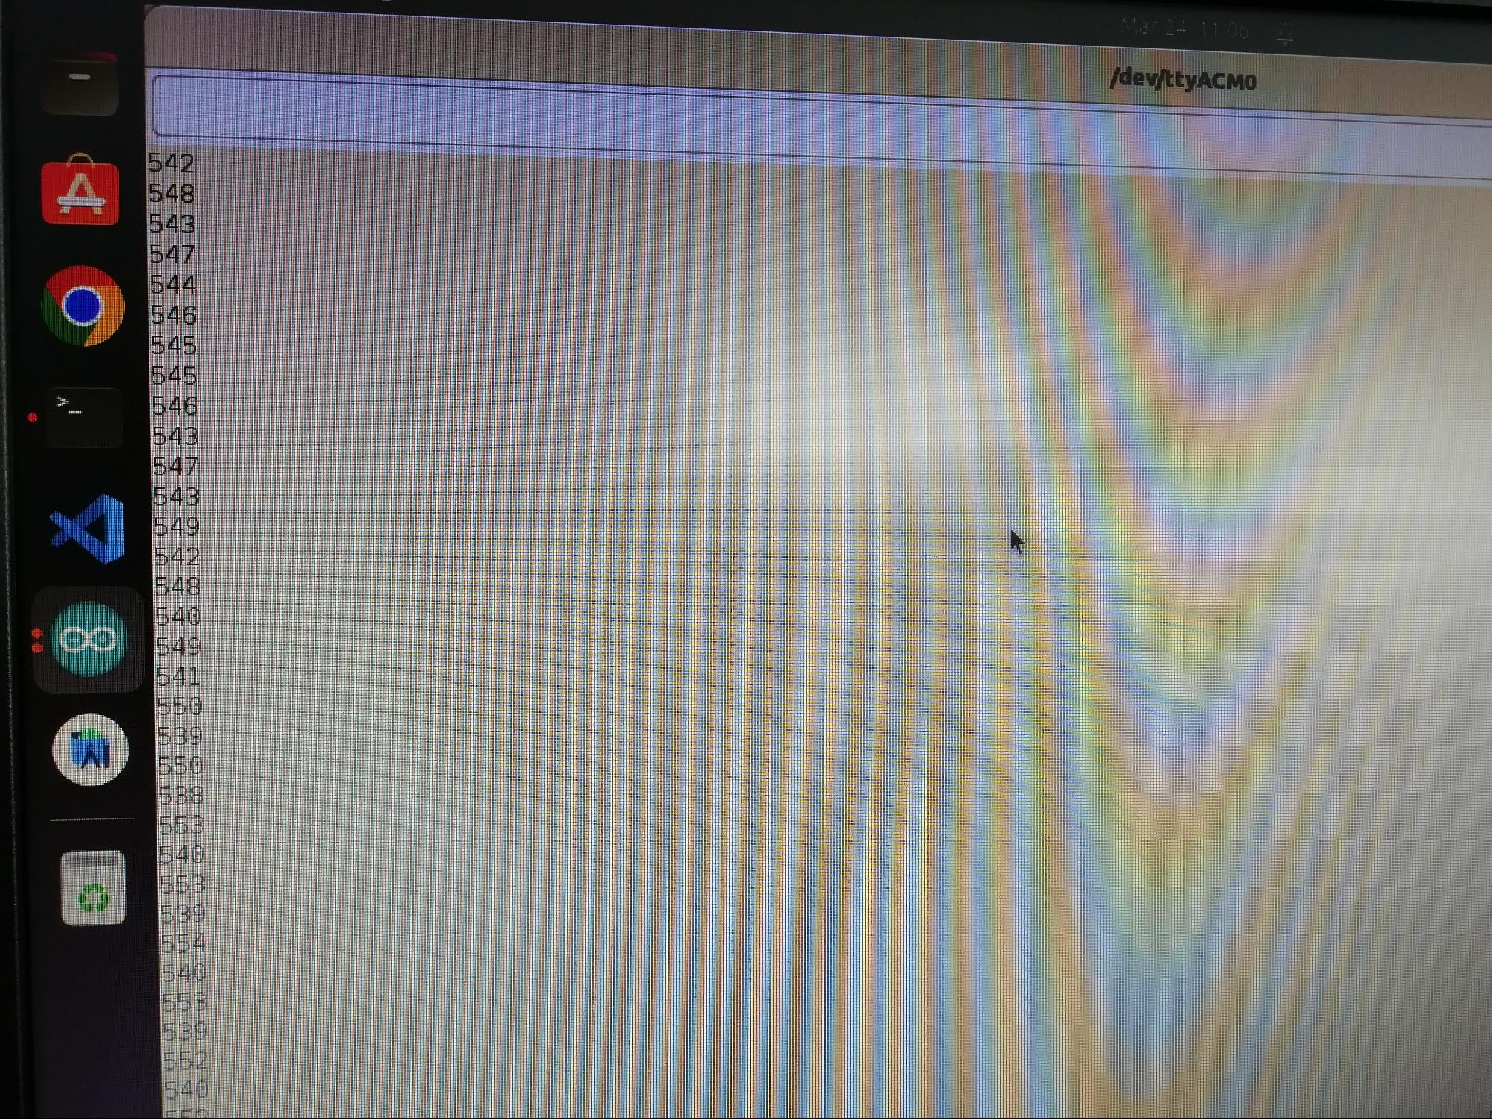

Step-6:- here you can see the reading of the pulse sensor.

**Practical 6 :- Interfacing the LDR Sensor with Arduino.**

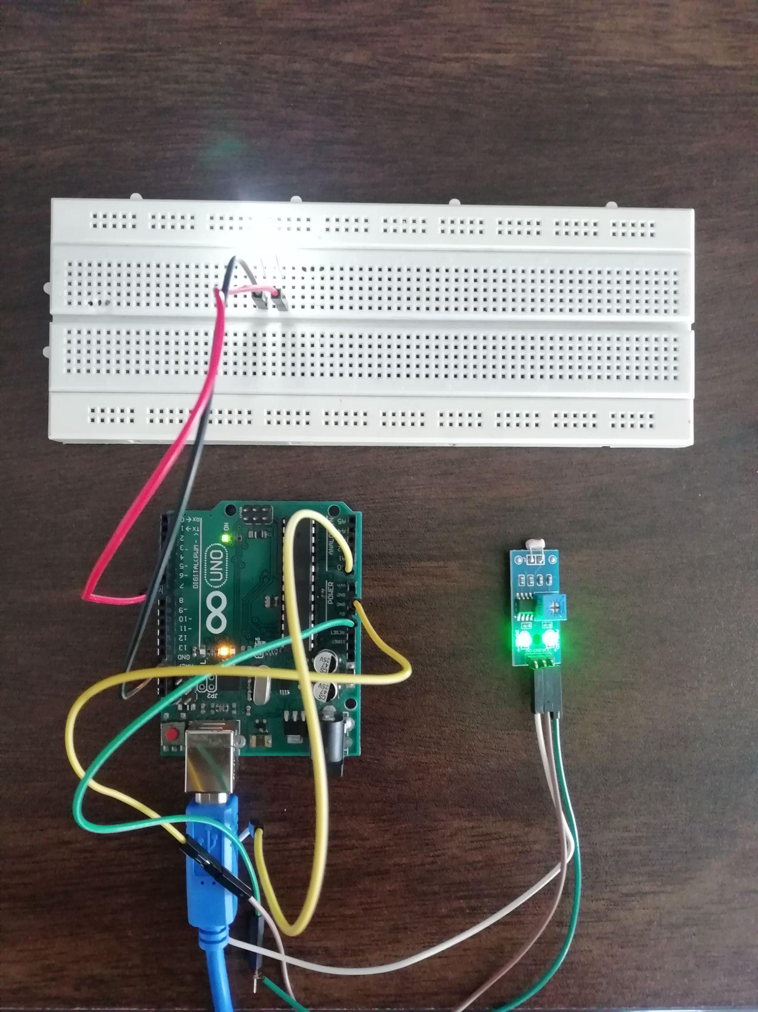

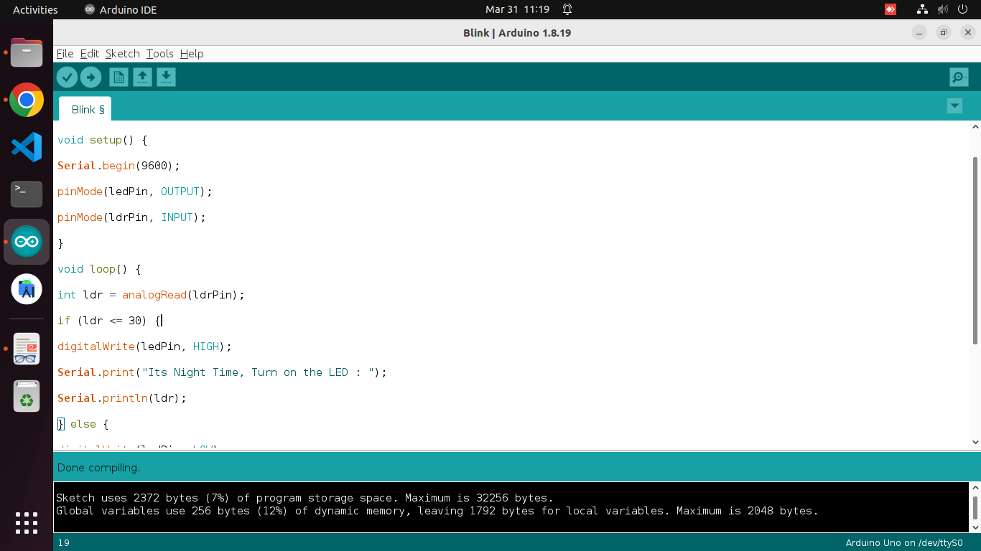

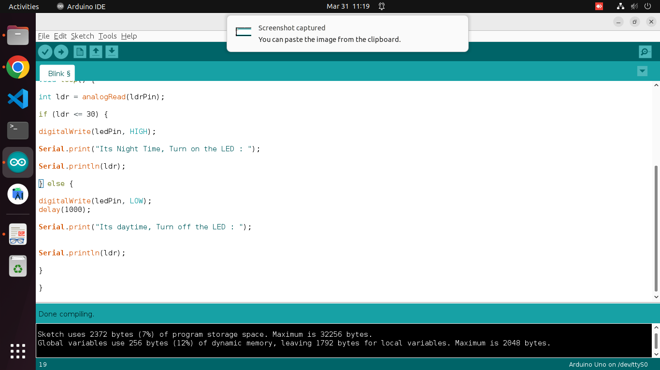

**Practical 7 :-Interfacing the Colour Sensor with Arduino and**

**Upload data to Adafruit cloud.**

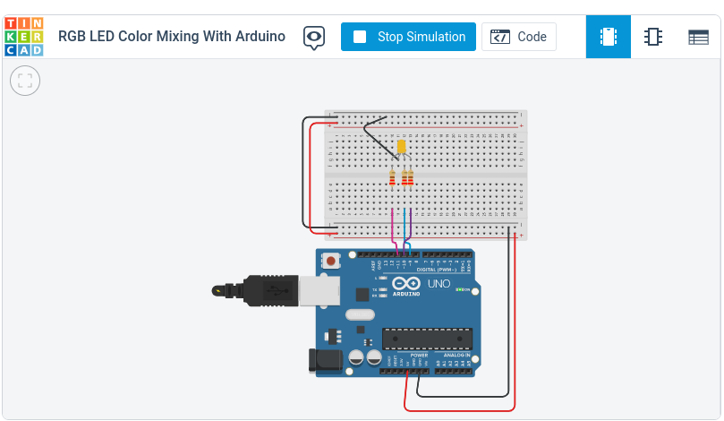

**Practical 8 :-Interfacing the pH Sensor with Arduino.**

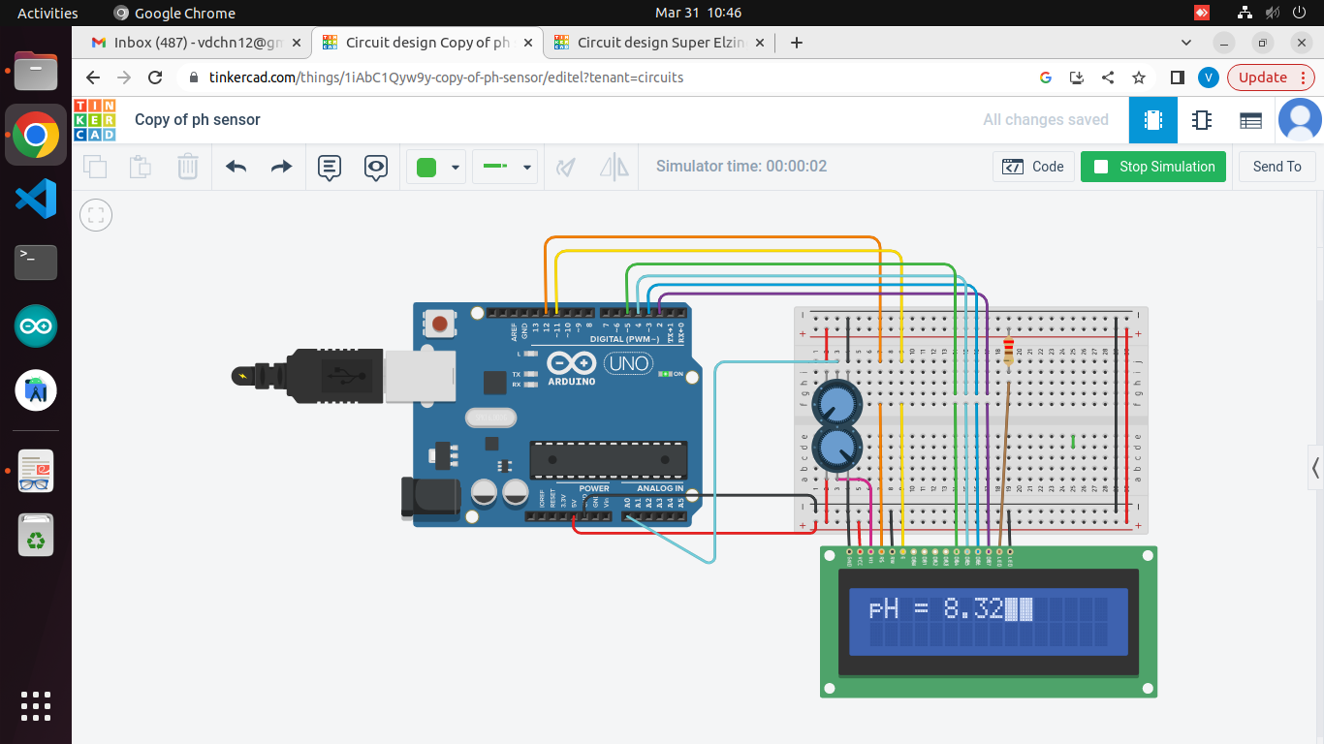

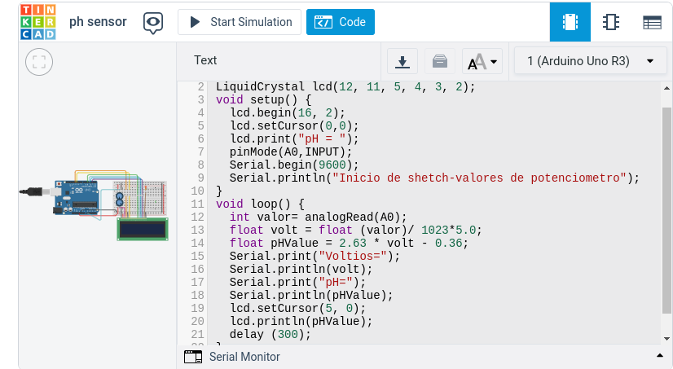

**Practical 9 :- Demonstration of Setup & Working of Raspberry**

**Pi.**

What is raspberry pi??

The raspberry pi is the single board computer system which was developed by the raspberry pi US foundation they launched in 2012.It can be used for the different types of projects and the various types of the code beginner and the code developers.

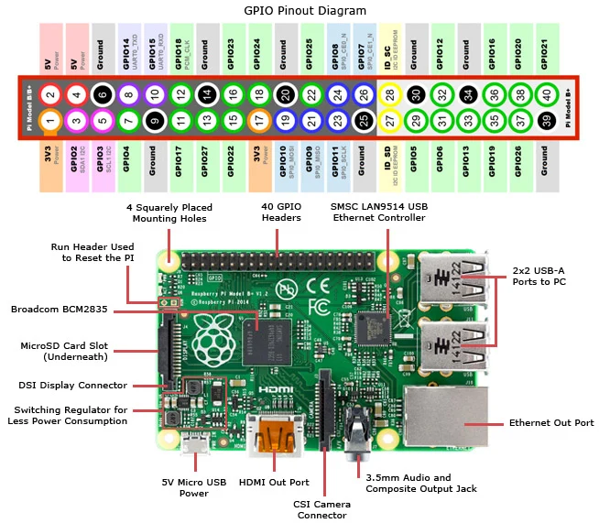

(The architecture of the raspberry pi single board)

Setup and the working of the raspberry pi:-

**Setup and the working of the raspberry pi:-Setup and the working of the raspberry pi:-**

The raspberry pi board comes with the different types of slots like the microsd card slot,usb slot,micro usb power,camera connector,audio output jack,5v power slot,hdmi in and hdmi out slot,ethernet output slot,40 GPIO headers,smsc lan9514 usb ethernet connector,broadcom bcm2835 etc.

The sd card slot is the main storage device to store the data or the os it is working like an external hard disk.first of all we have to install the os in that particular sd card then we have to use it on the raspberry pi board.the raspberry pi supports the operating systems like linux,arm,and mac.you can use the other method like bootable pendrive cause there is the 2 usb ports.

There are different sizes and different brands of memory cards but the Raspberry Pi supports 64gb memory cards.

Before we are going to use the raspberry pi board we need to connect the keyboard,mouse,hdmi to the vga cable converter if you connect it with the pc cause our monitor supports the vga cable only,insert the audio jack if it is required.

Connect the ethernet cable when you need internet otherwise it will connect the wifi directly.if you want to perform the input and output task so you need to connect the gpio 40 pins to breadboard for executing the task.

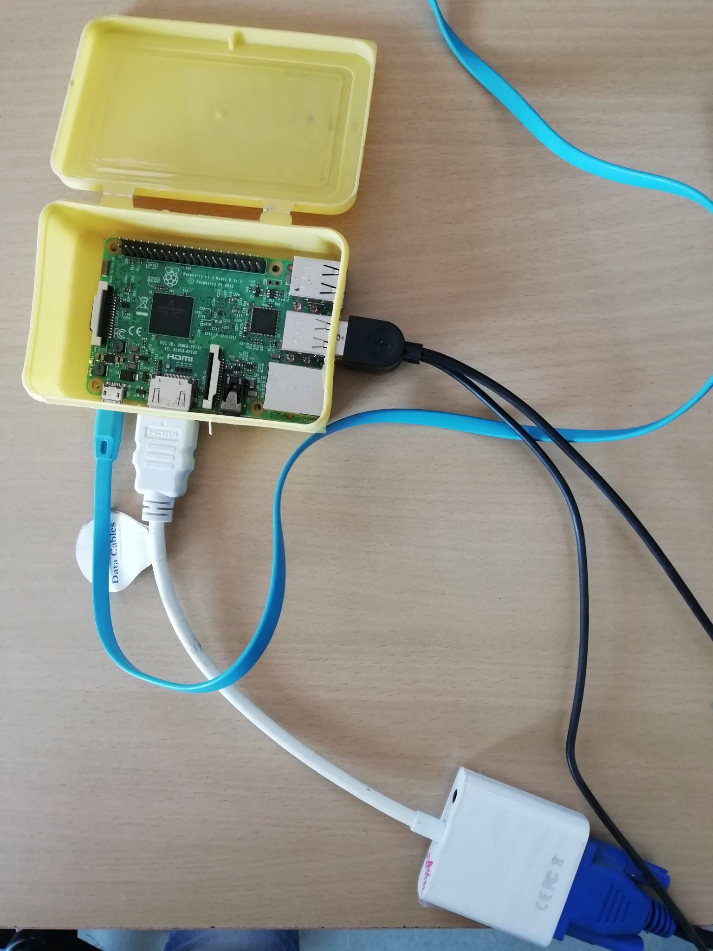

(after the connection of raspberry pi)

**Practical 10 :- Connect Raspberry Pi with your existing system**

**components.**



1)USB ports — these are used to connect a mouse and keyboard. You can also connect other

components, such as a USB drive.

2)SD card slot — you can slot the SD card in here. This is where the operating system

software and your files are stored.

3)Ethernet port — this is used to connect Raspberry Pi to a network with a cable.

Raspberry Pi can also connect to network via wireless LAN.

4)Audio jack — you can connect headphones or speakers here.

5)HDMI port — this is where you connect the monitor (or projector) that you are using to display the output from theRaspberry Pi. If your monitor has speakers, you can also use them to hear sound.

6)Micro USB power connector — this is where you connect a power supply. You should always do this last, after you have connected all your other components.

7)GPIO ports — these allow you to connect electronic components such as LEDs and buttons to Raspberry Pi.

.